**1) The Solution has 2 projects as shown below**

-palindrome – which contains the actual console program

-PalindromeUnitTests – Unit test cases for ‘palindrome’ console program

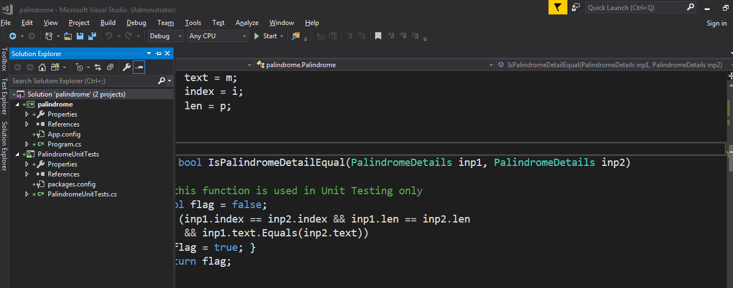

**2)To run the test cases:**

From the TestExplorer -> Click RunAll

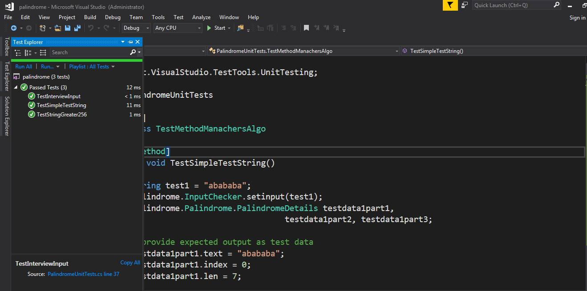

OR

Right click on any of the [TestMethod] in the file PalindromeUnitTests.cs

